**TECHNOCRATS SUMMER TASK**

**TASK-3**

**BASIC MODULE**

**SUBMITTED BY:**

Rohan Bhojwani

(Robocon-Electrical)

**CYTRON SC16A:**

<https://www.mikrocontroller.net/attachment/59378/SC16A_User_s_Manual.pdf>

Above link is user manual for the Cytron SC16A. The following report will be based on extracting the main stuff and about what I understood.

**Some specials features of the driver:**

* **16 channels:** Servo driven independently
* **Extendable to 32 Channels:** Two controller linked together to drive 32 servos. ( basically says that two controllers can be joined together to connect 32 servos)
* **Optional Position Reporting:** User may request position of an individual servo. (basically says that just like we can set the degree of movement we want in servo similarly we can set it for all 16/32 servo attached)

**Circuit board connections:**

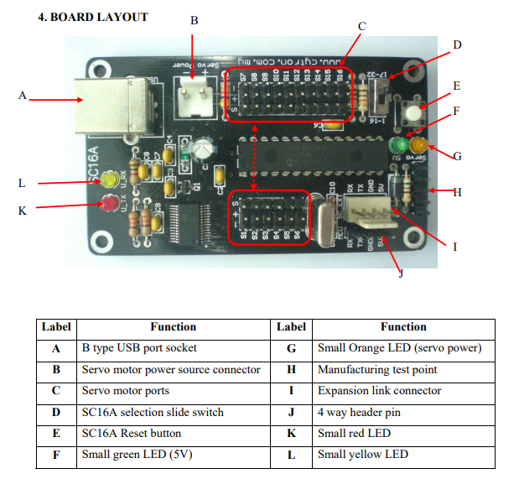

**Connecting the servo to the driver module:**

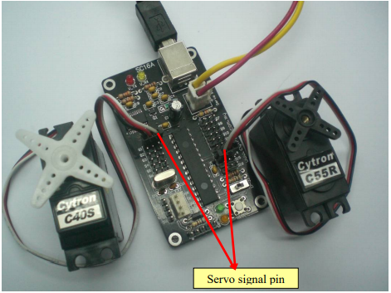

Generally the white color wire which is signal wire has to be inserted in the nearest pin to the controller chip. The black wire of servo is connected to outer edge.

**Power supply:**

SC16A needs its own power; it can either come from USB power or other microcontroller board power. However, the standard power source is 5V for SC16A.

Caution:

Please beware that, only one host can be connected to SC16A at a moment. Either computer or a microcontroller. DONOT connect two hosts (computer and microcontroller) to a SC16A at the same time.

**Setting up two driver modules together for 32 channel:**

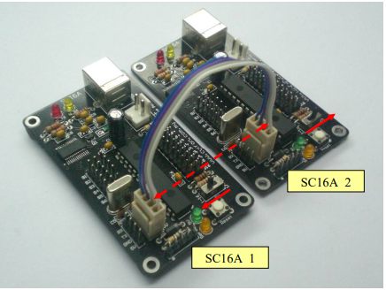

**Few points to be noted down while connecting two driver modules:**

* Link up both SC16A with the cable. Following figure shows the sample connection. Please ensure the 2510 connector is being connected**, DO NOT connect to header pin** , the header pin is only use for connection to host, microcontroller.
* The slide switch “SW” for SC16A_1 (board 1) **should be pushed towards inside board** (1-16), while for SC16A_2 (board 2) should **be pushed towards outside board** (17-32).
* For SC16A_2, servo connected at “S1” will be recognized as “S17” in software. This applied to the rest of servo port on SC16A_2. Every label should be added with 16 during software development.